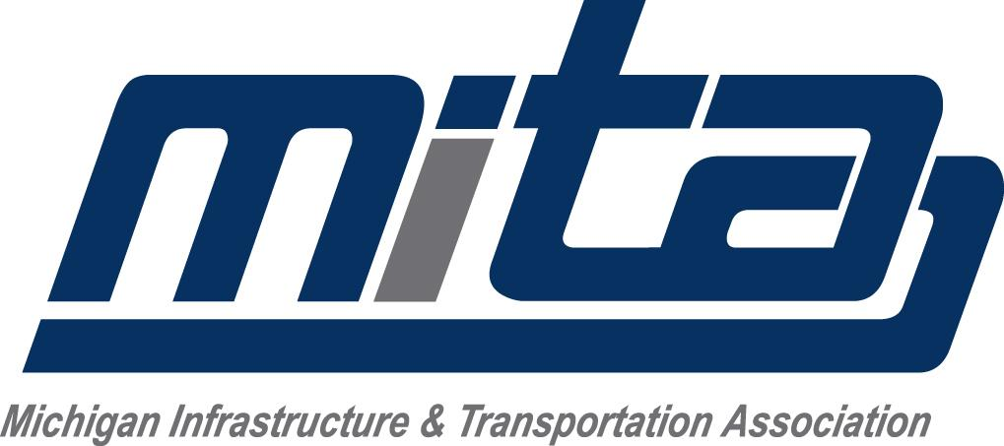

2023-2026 INDUSTRY ADVANCEMENT FUND - TEAMSTERS
Report On All Teamster Employees Performing Road Construction Work in the Counties of Wayne, Oakland, Macomb, Washtenaw, Monroe, St. Clair, Genesee, Shiawassee, Lapeer

INSTRUCTIONS:
- Complete original and mail to: MITA, PO Box 1640, Okemos, MI 48805-1640 (Retain a copy for your records.)
- Make check for total amount due to: MITA/I.A.F.
- All contributions are due by the 15th of the month following the month in which the work is performed. Report on all payroll periods ending in the month.
- If you have any questions concerning this report, please call 517-347-8336.
- If no Teamsters were employed during the month shown below, check the blue box to the right.

DATE OF REPORT: WORK MONTH:

COMPANY: ________________________________________________________________
ADDRESS: ________________________________________________________________
CITY and STATE: ________________________________________________________________
ZIP: TELEPHONE: ________________________________________________________________

REMITTANCE:
TOTAL Hours Worked By All Company Teamsters (ROAD)

TOTAL HOURS AMOUNT

x $0.12 cents =

